Product Price List - 2025
Chipmart india
product team

Product ID | Product Name | Description | Image | Price (INR) | Availability | Stock
P001 | Wireless Mouse | Ergonomic 2.4GHz mouse with USB dongle | 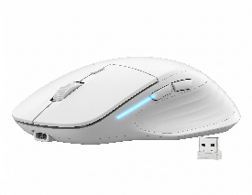 | ₹ 499 | ✅ | 120
P002 | Mechanical Keyboard | RGB backlit gaming keyboard | 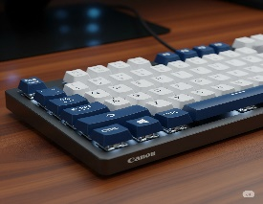 | ₹ 1,999 | ✅ | 85
P003 | SSD 1TB | 2.5" SATA III solid state drive | 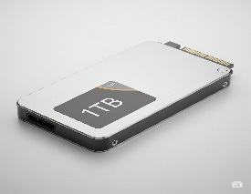 | ₹ 4,499 | ✅ | 60
P004 | Graphics Card RTX 4060 | 8GB GDDR6 for high-end gaming | 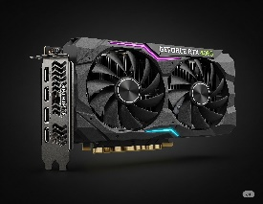 | ₹ 29,999 | ❌ | 0
P005 | 24" LED Monitor | Full HD IPS panel with HDMI/VGA ports | 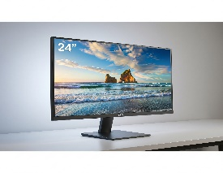 | ₹ 8,999 | ✅ | 40
P006 | Laptop Cooling Pad | 5-fan design with LED lighting |  | ₹ 1,299 | ✅ | 72
P007 | USB-C Hub | 7-in-1 adapter for laptops | 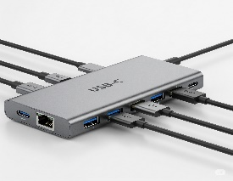 | ₹ 2,199 | ✅ | 50
P008 | External HDD 2TB | USB 3.0 portable hard disk |   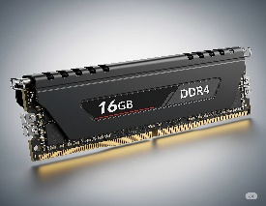  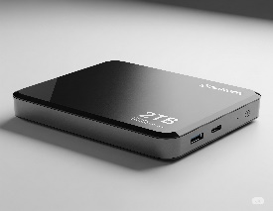 | ₹ 5,999 | ❌ | 0
P009 | RAM 16GB DDR4 | 3200MHz desktop RAM |  | ₹ 3,799 | ✅ | 100
P010 | Gaming Headset | Surround sound with mic |  | ₹ 2,499 | ✅ | 35
P011 | Wi-Fi Adapter | Dual band USB wireless adapter | 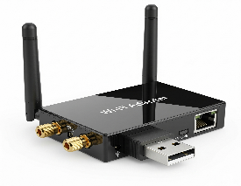 | ₹ 799 | ✅ | 140
P012 | Power Supply 650W | Modular SMPS for gaming PC | 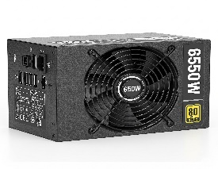 | ₹ 4,250 | ✅ | 25

Terms and Condition:
- Prices valid until December 2025.
- Contact us at 📞 +91 98765 43210 or email us at sales@chipmartindia.com for bulk discounts.
- All prices exclude taxes.

